**FINAL PROJECT REPORT**

**HOTEL MANAGEMENT SYSTEM**



**PREPARED BY:**

**Cabinet kumar shah**

**11812420**

**K18PV B51**

**INTRODUCTION:**

My project title is “HOTEL MANAGEMENT SYSTEM”. I have tried my level best to make the complicated process of Hotel management system as simple as possible using python code, tkinter and filehandling etc. Moreover I have used DFD’s (data flow diagrams) and ER Daigram (Entity Relationship Daigram) to explain the process to use the Hotel management system. I have tried to design the project in such a way that customer may not have any difficulties in using the hotel management system. The main purpose of my project is to perform each employee’s activity in computerized way rather than manually which is time consuming.

This project can be used by two types of users and they are:

1. Customers
2. Administration (Management of the Hotel)

**AIM:**

In my project on “Hotel Management System”, I have tried my level best to show how the Data/Information in hotels is managed through the use of computer. This is just an overview of management in hotels. This has been achieved by dividing the projects into various modules. Customers is provided with different services like checking in, checking out, etc. If the customer want to enquiry about the hotel rooms whether it is occupied or vacant then they can check by using direct room numbers. Moreover, customer/administration of the hotel can have enquiry about the persons by their room nos. and also can see the complete list of people in the hotel. Administration of the hotel can compute bills and can forward to the customers. Customers can give their feedback.

My major aim was to design a project on Hotel management system with different modules in it. I have designed a graphics user interface using Tkinter. I have tried my level best to give a beautiful view to GUI. Through this project I have tried making the small hotel management system website where I have used different pages to explain different features of my project. I have collected (or stored) all the data in the files as well as in the database. I have used SQLLITE to store all the information given by the user to store in the database. Moreover I have tried to making payment gateway of two different types (i.e by credit card/ debit card or by hand cash). I have made first screen where I have asked the user to register to our website and then only they are supposed to use the hotel facilities. After all I have designed a forgetpassword screen where user can retrieved their forgot password by passing some security purpose question. After login into the home page user will come to know about the different modules.

I have tried to computerize the following function that are performed by the system.

1. Room detail function
2. Opening a new room
3. Checking in and checkout detail function
4. Admission of new customer
5. Check-In of the customer
6. Check-out of the customer
7. Checking (or monitoring) detail of employees
8. Room details
9. Total number of customer in the hotel
10. Individual customer report
11. Enquiry of customer
12. Enquiry of rooms
13. Enquiry of employees

**MOTIVATION:**

After completing the project I came to know various requirements needed to develop a simple project on hotel management system. I get to know how the modules are made to give a proper view to a hotel management system. Moreover, I have motivated to enjoy the code. As I have a little fear of using different other libraries beyond the syllabus, but through this project I have become fearless to use any libraries. Now I can code for any project on python using different modules in it. This is only the major motivation that I get after and during the completion of this project on Hotel Management System.

**OBJECTIVES:**

Following are the major objectives of my project on hotel management system as follows:

1. Keeping the records of admission of customers.
2. Keeping the records of admission of new employees.
3. Facilities provided by hotel are fully utilized in effective and efficient manner.
4. Keeping the records of the payments made by the customer during check-In and check-out.

**ENTITY RELATIONSHIP DIAGRAM**

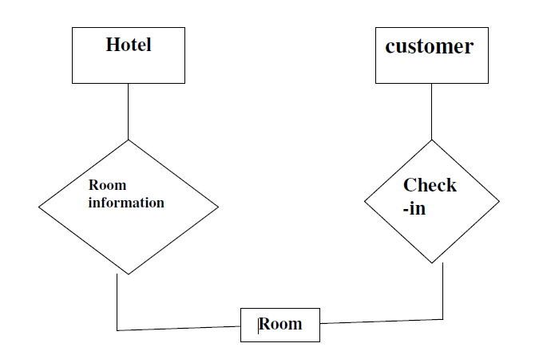

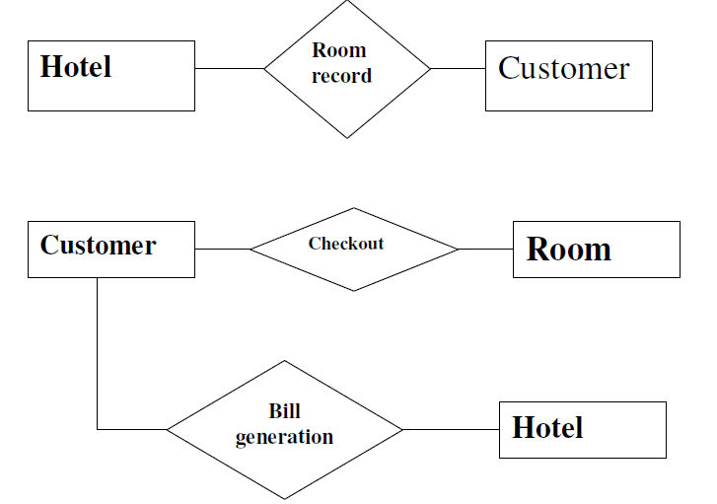

**DATAFLOW DIAGRAM FOR OPENING A NEW ROOM**

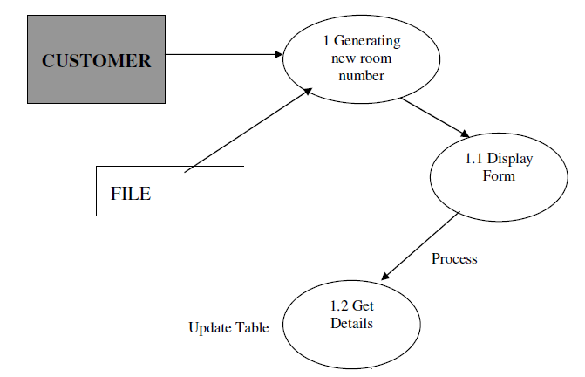

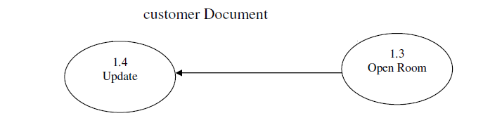

**DATAFLOW DIAGRAM FOR CHECKING IN A NEW CUSTOMER**

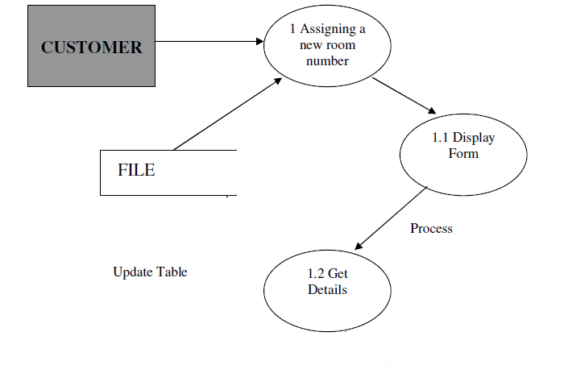

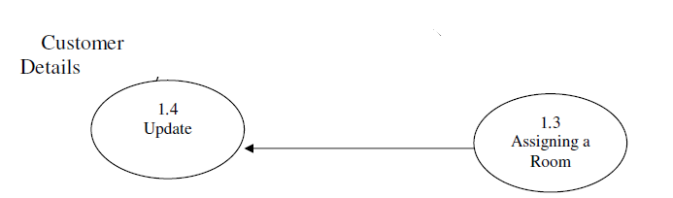

**DATAFLOW DIAGRAM FOR CHECKING OUT A CUSTOMER**

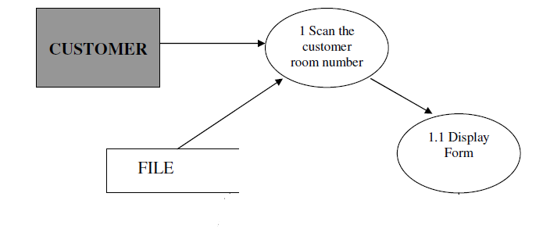

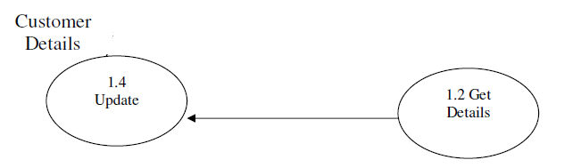

**DATAFLOW DIAGRAM FOR RECEIPT/BILLS FOR CUSTOMER**

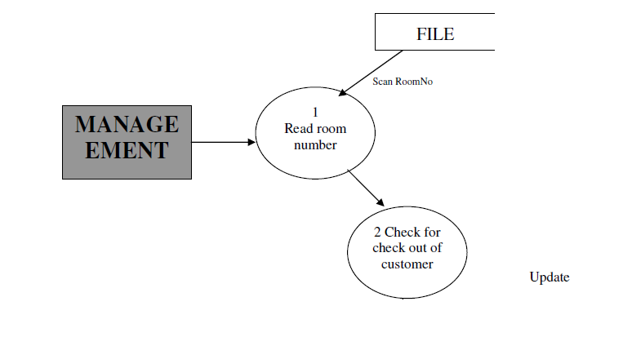

Customer

**MODULES:**

1. **LOGIN PAGE:**

This module is used to take user data from then and then to allow then to enter into the homepage. In this modules I have used two different entry box where I have taken username and password.

1. **Sign up / register page:**

This module is used to take all the valid data from the user/ customer to keep their records in the database. After completing the registration form when the user/ customer press the submit button they will be navigated to the homepage.

1. **Forgot password page:**

This module is used to retrieve the password when the user forget their password after registration to the system. In this modules I have used some verification steps when they need to verify that they are the correct person to get their password back.

1. **Booking ( check-In and Check-out):**

This module help user to fill all their detail to check-In the hotel and also user can check-out from the hotel.

1. **Monitoring the database:**

This module help the administrator as well as the customer to monitor the database.

1. **Bill / payment:**

This modules is used to help user to make payment by hand cash and by credit card / debit card.

1. **Enquiry for rooms & customers:**

This module is used customer and administrator to make enquiry for rooms as well as customers.

1. **Enquiry for employee details:**

This module is used to help administrator and customer to make enquiry for employee details.

1. **About us:**

This module is used to help the user to know about the hotel facilities and many more about the hotel.

1. **Over-view:**

This module is used to help user to know the user to see the overall view of hotel.

1. **Location:**

This module is used to help user to see the exact location of the hotel.

1. **Hotel Gallery:**

This module is used to help user to see the gallery of the hotel.

**LIBRARY USED**

* **Os:**

I have used this library to use operating system dependent functionality and to interact with the underlying operating system in several ways such as working with the files, database, and can move file around, etc.

* **Sys:**

I have used this library to access all the functions and variables that are used to manipulate different parts of the python runtime environment.

* **Subprocess and call:**

I have used this library to connect my different program code together whenever the button is pressed the targeted program gets executed.

* **Tkinter:**

I have used this library to make GUI. Also to make attractive GUI using its different features that this library provides me to use.

* **SQLITE:**

I have used this library to store data in the database.

* **Pickle:**

I have used this library to dumb the data into the file and also to load it from the files whenever there is use of the existing data from the files.

* **Time:**

I have used this library to generated time on my registration page as per the time that is used by my system.

* **Webbrowser:**

I have used this library to use hyperlink in some of the buttons present on the homescreen.

**SOME OF THE SCREENSHOTS OF MY CODE**

🡪I have used this code to create GUI page of registration

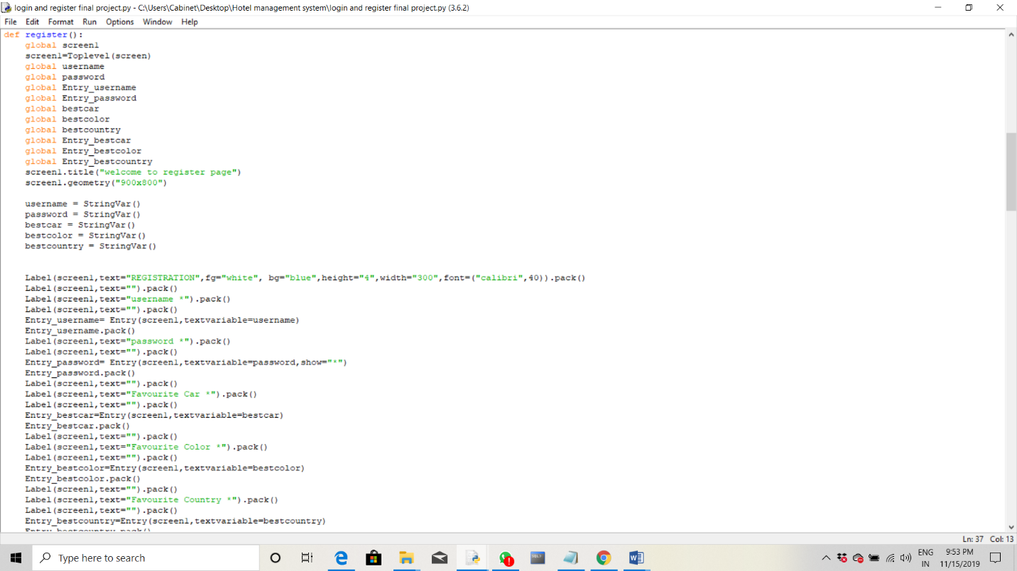

🡪I have used this code to save data in the database as well as in the file

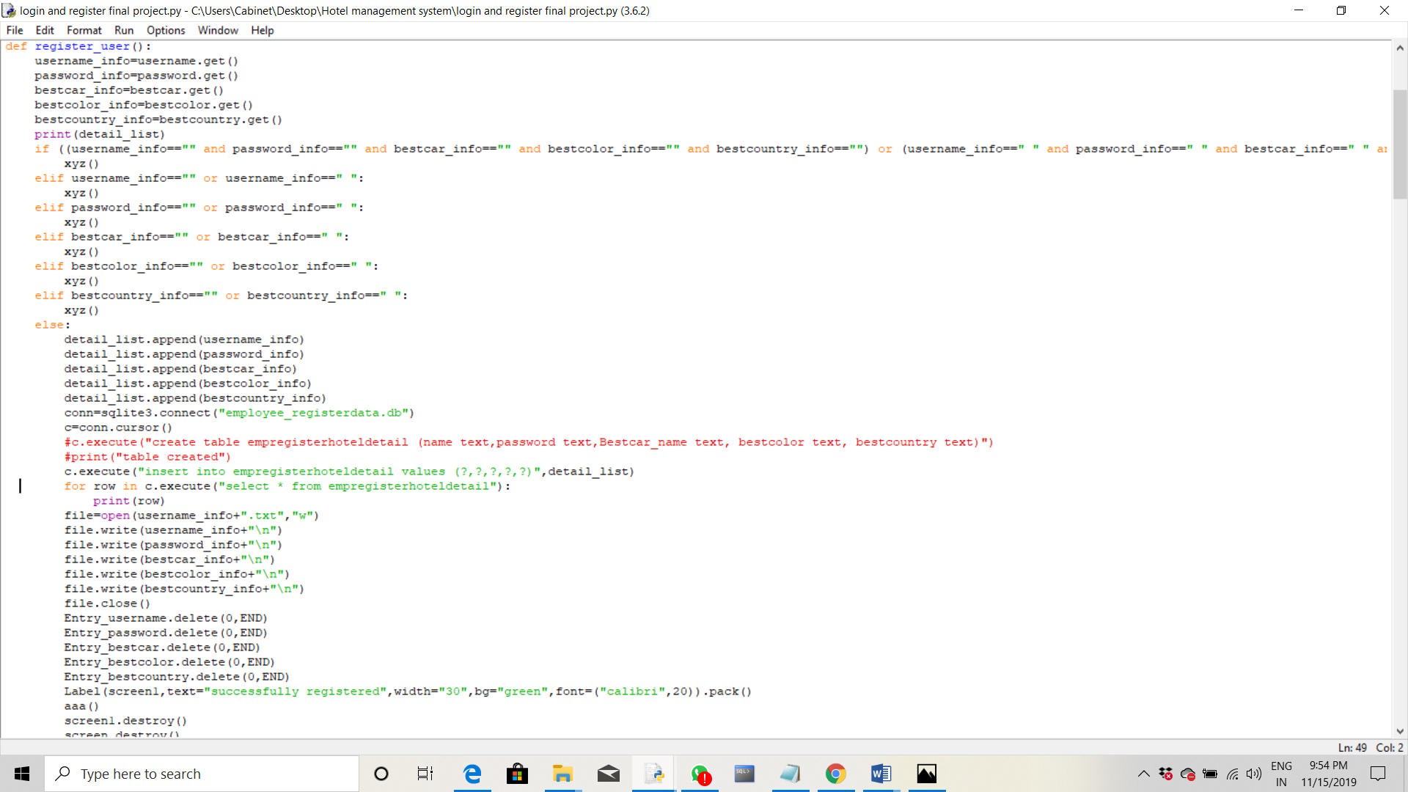

🡪I have used the code to create the login GUI

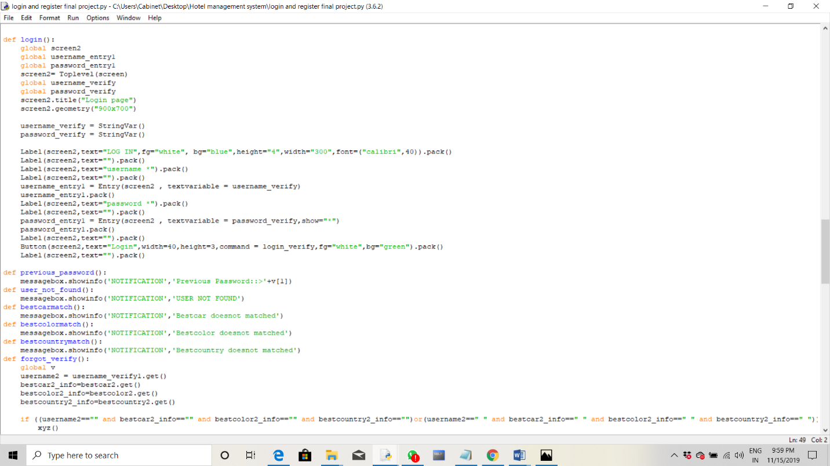

🡪I have used the code to verify the login

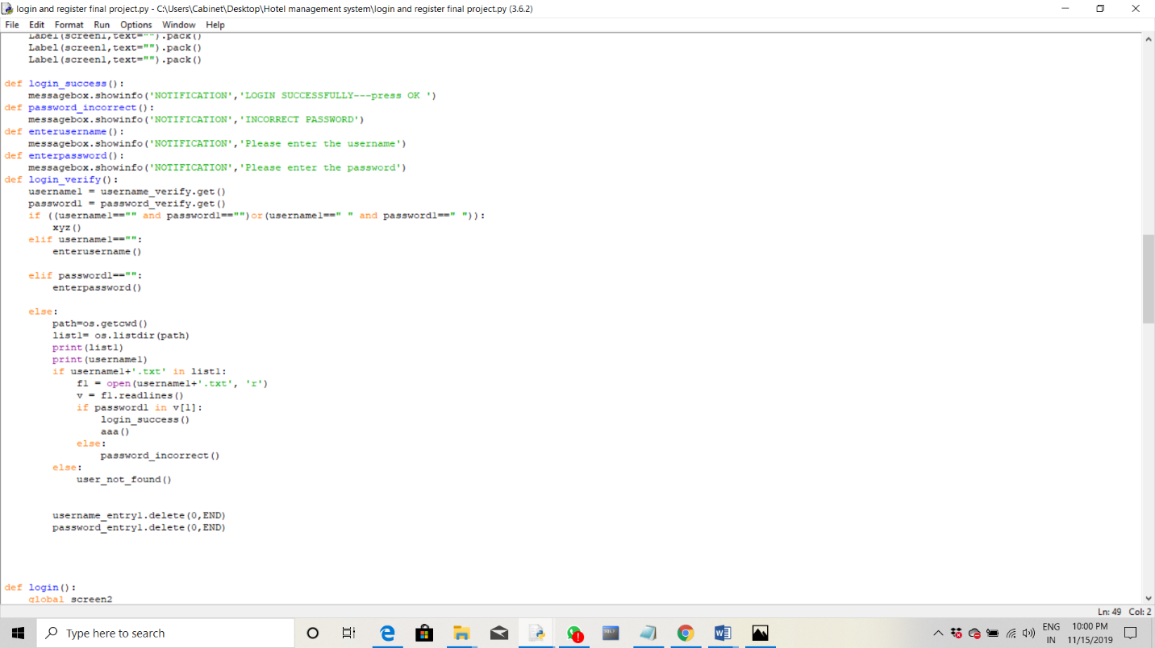

🡪I have used the code for GUI of Forgot-password page

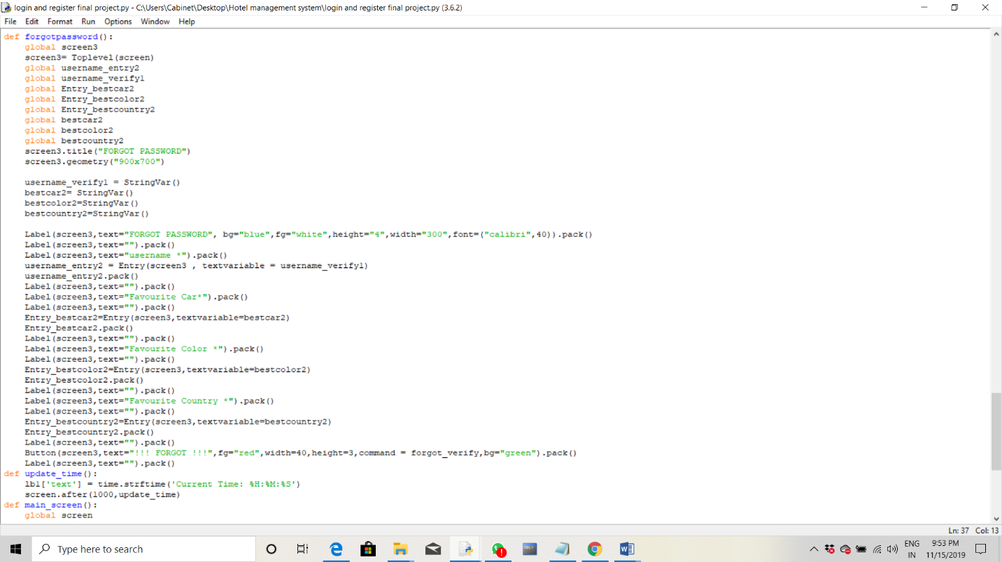

🡪I have used the code to verify forgot password

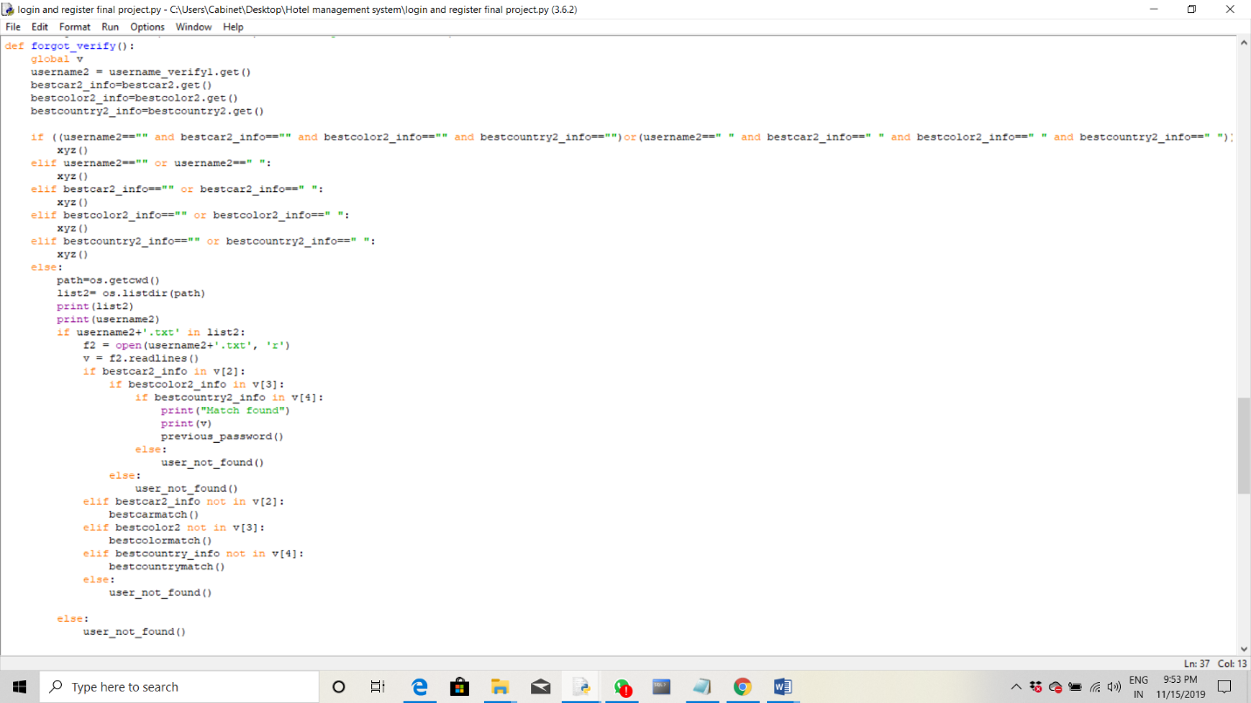

🡪I have used the code to make GUI of Home screen

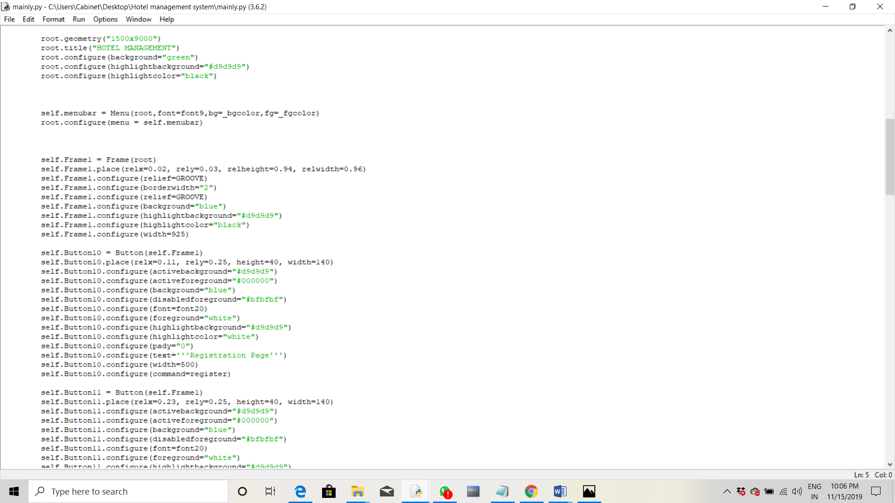

🡪I have used code to call different code whenever the button is pressed by the user/administrator.

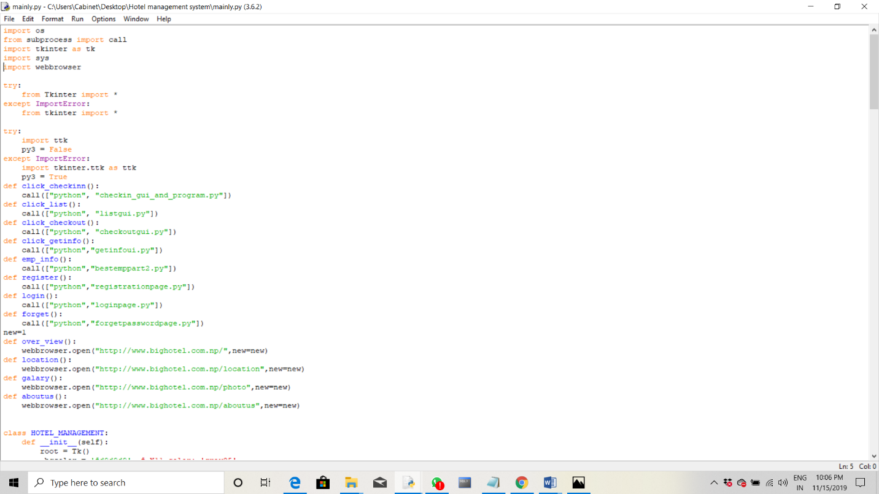

🡪I have used the code to save the data during check-In by the customer

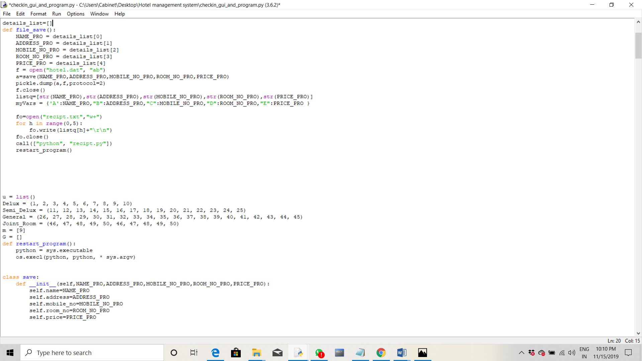

🡪I have used code to make GUI of check-In module

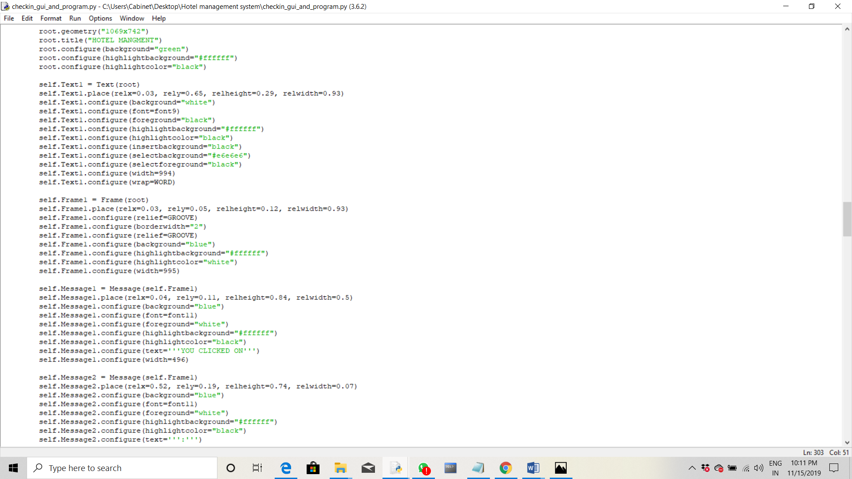

🡪I have used the code to show receipt along with GUI

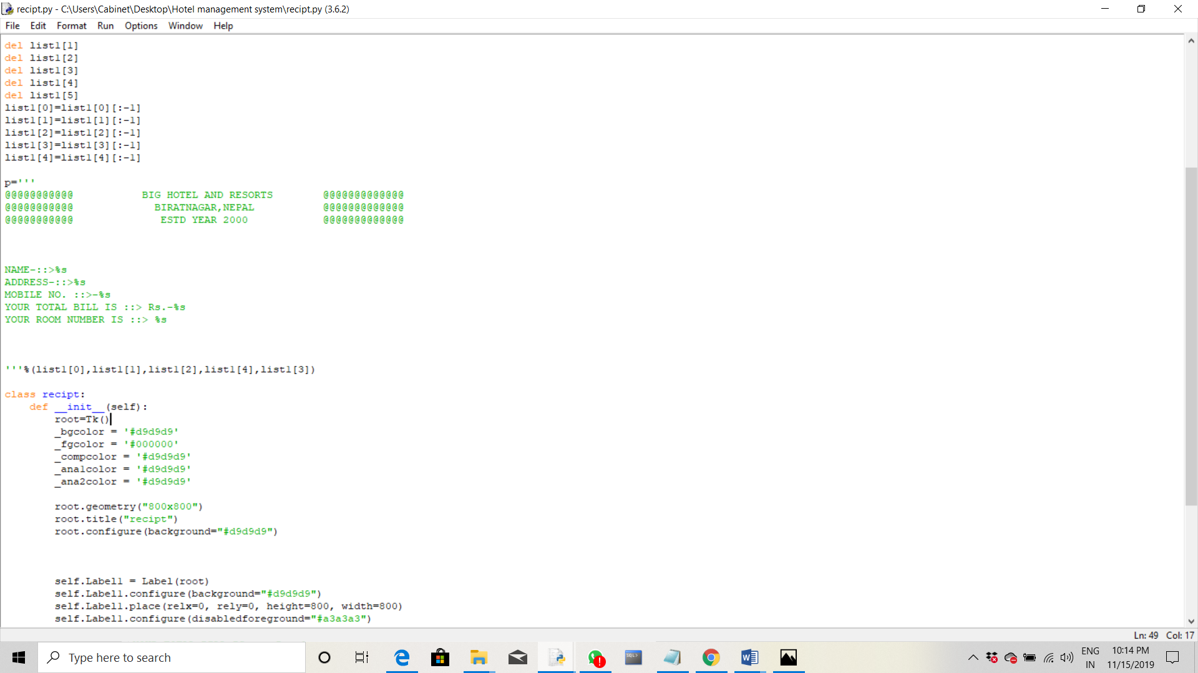

🡪I have used the code to show the guest list

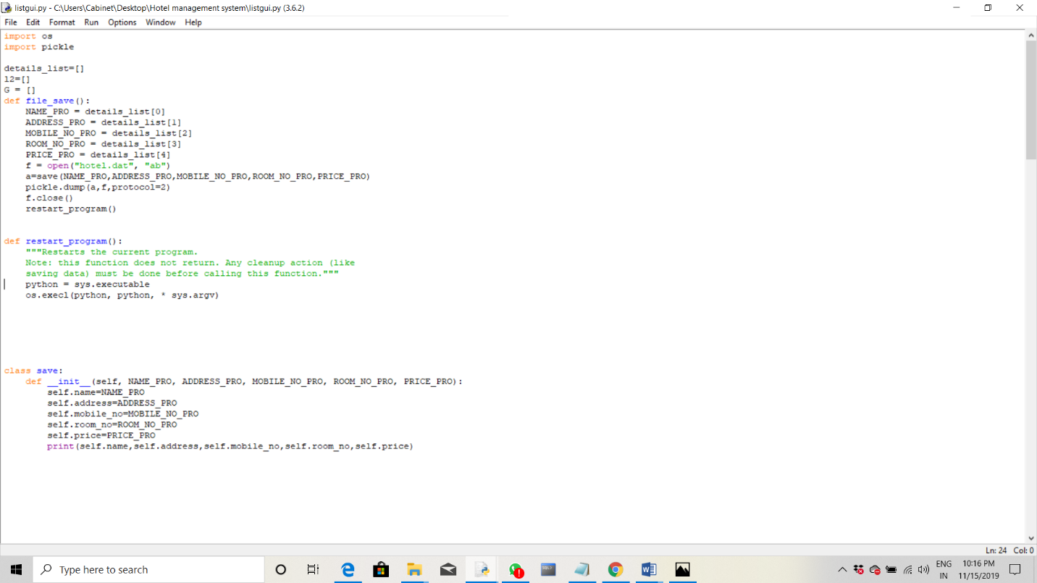

🡪I have used code to make GUI of show guest list.

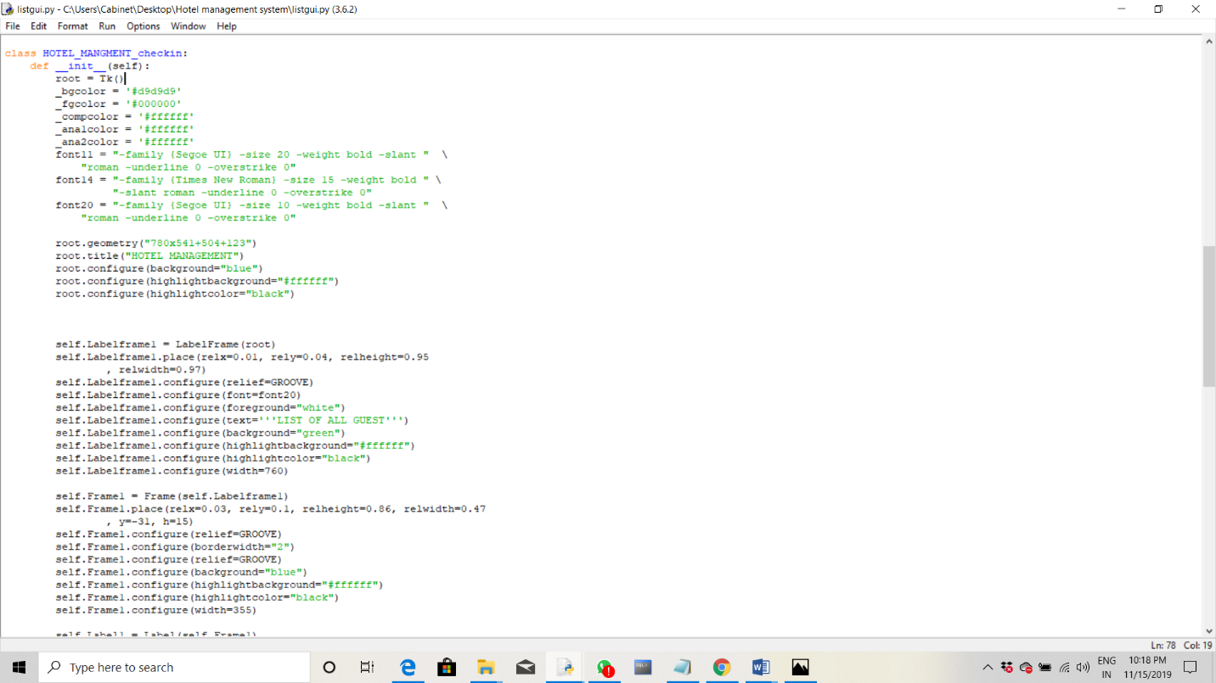

🡪I have used to code to show employee list using GUI

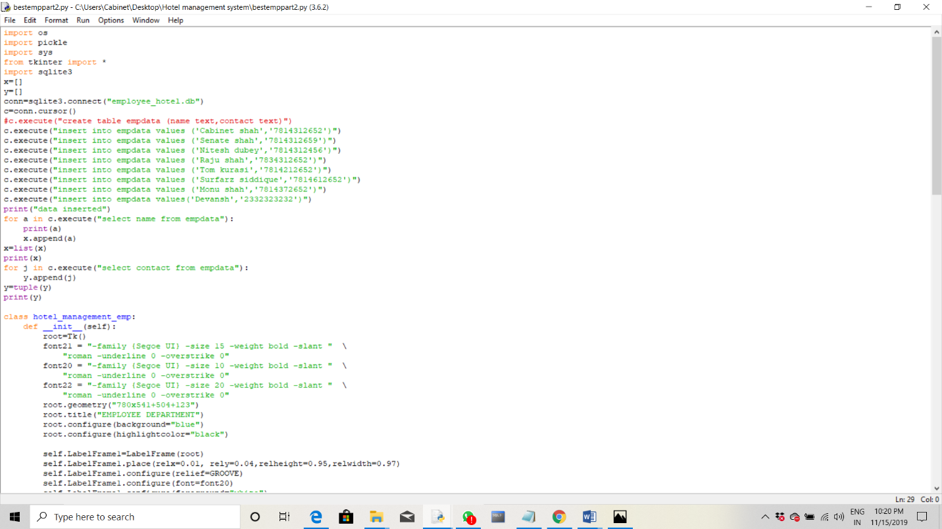

🡪I have used code to make check-out module

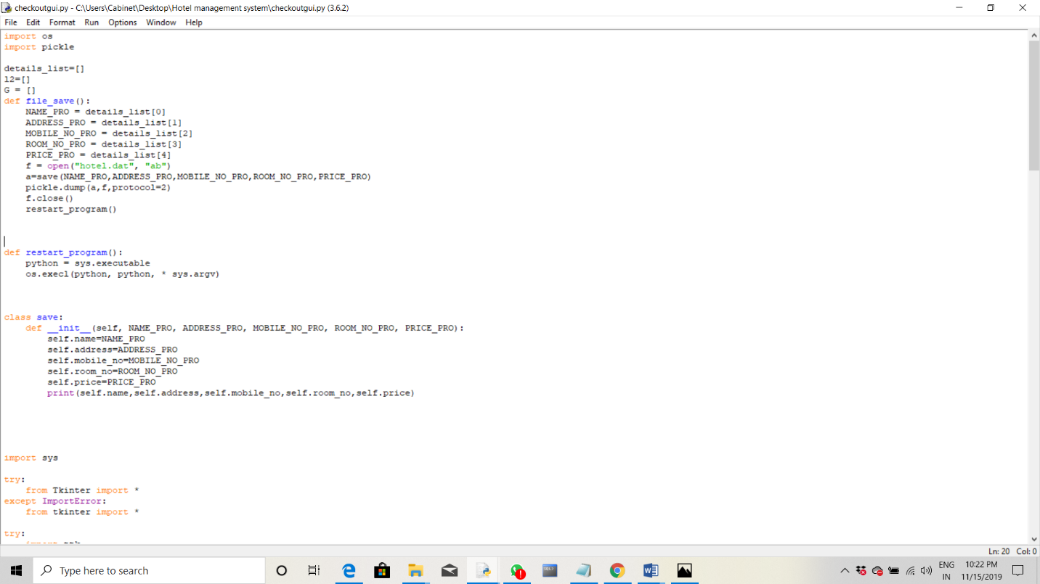

🡪I have used code check-out GUI

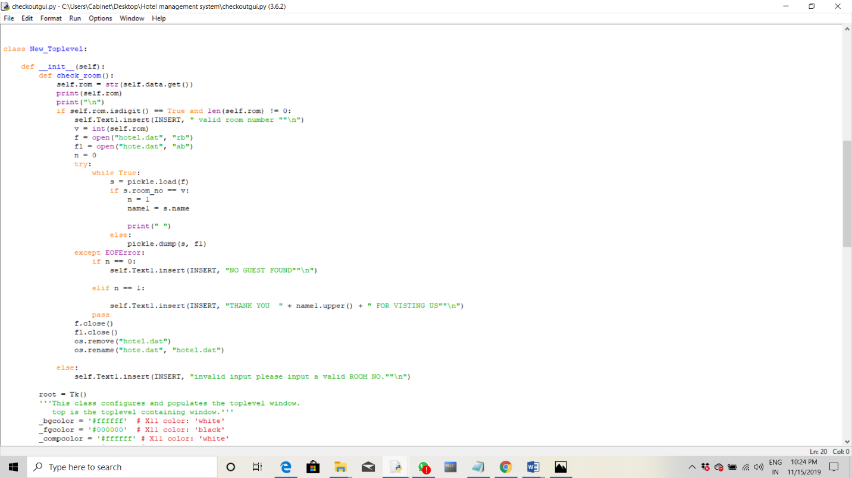

**SOME OF THE SCREENSHOTS OF MY GUI**

🡪GUI of Font screen

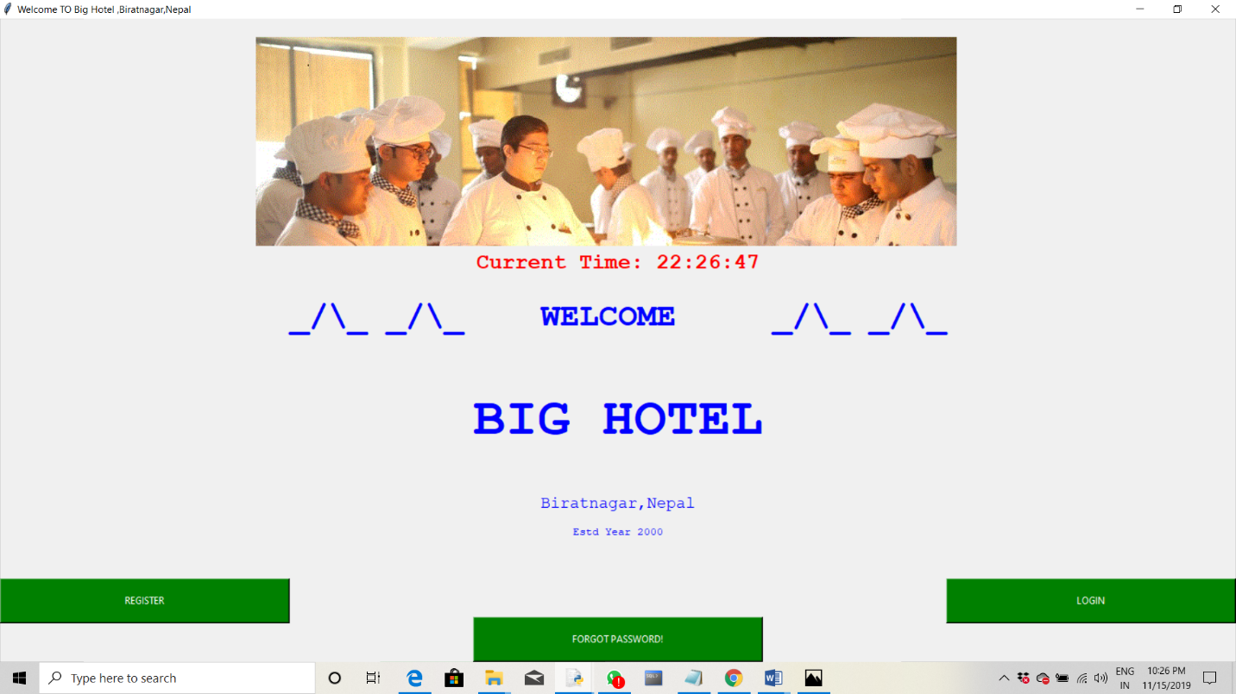

🡪GUI of Login screen

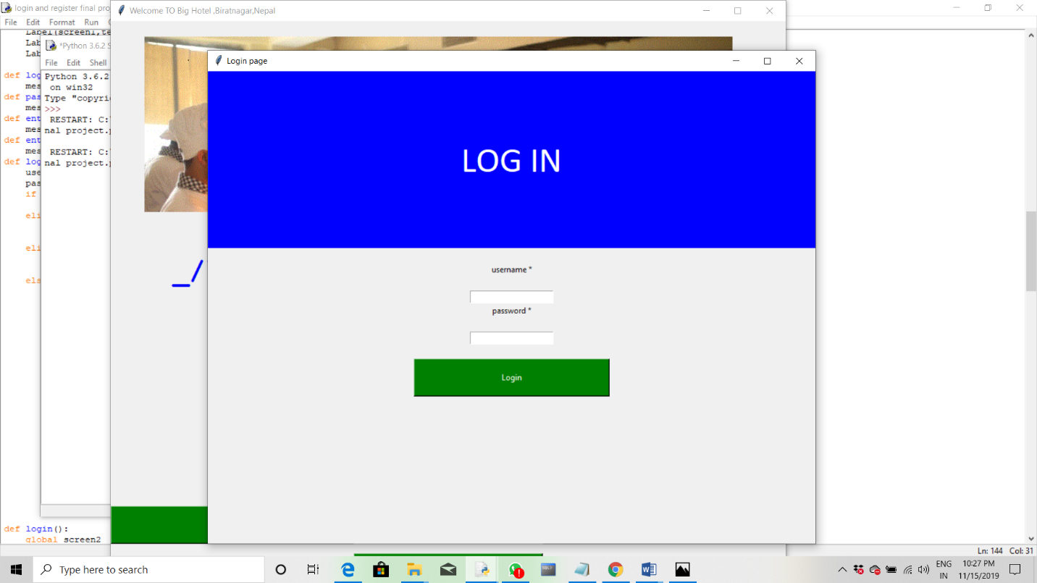

🡪GUI of Forgot password screen

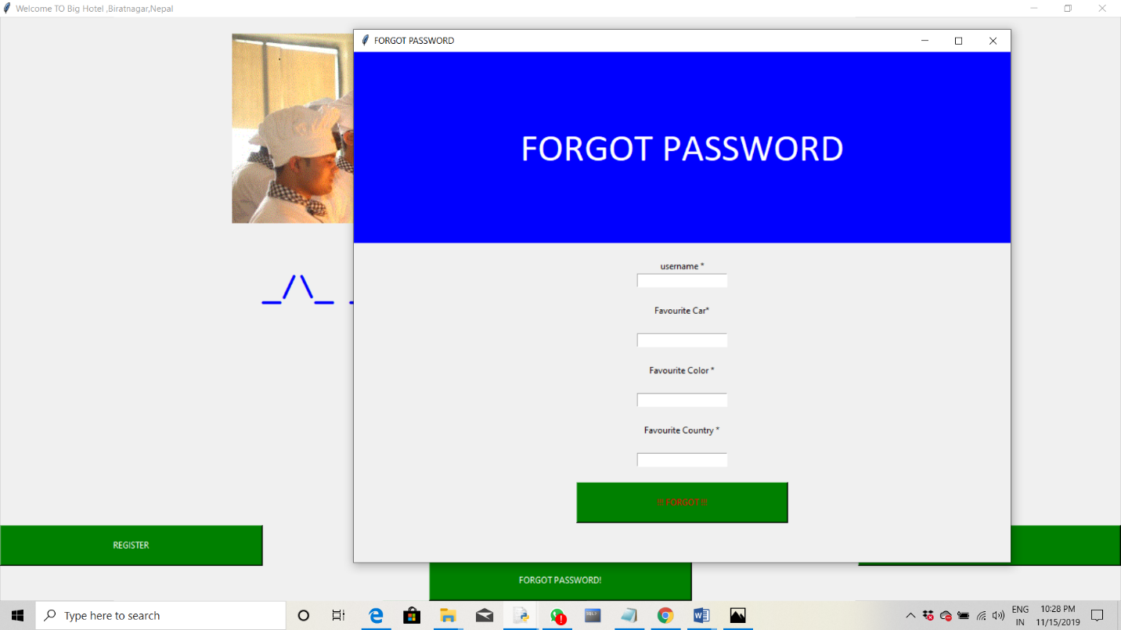

🡪GUI of Registration screen

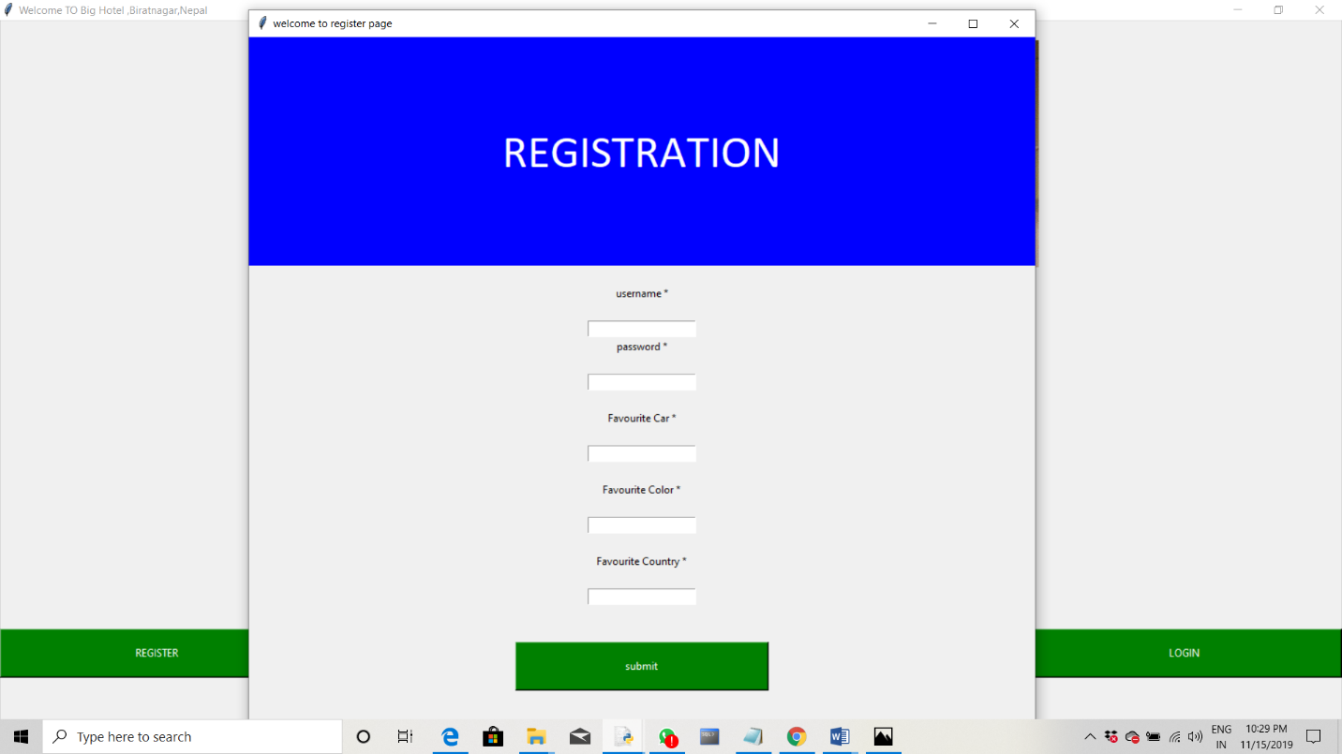

🡪GUI of Home screen

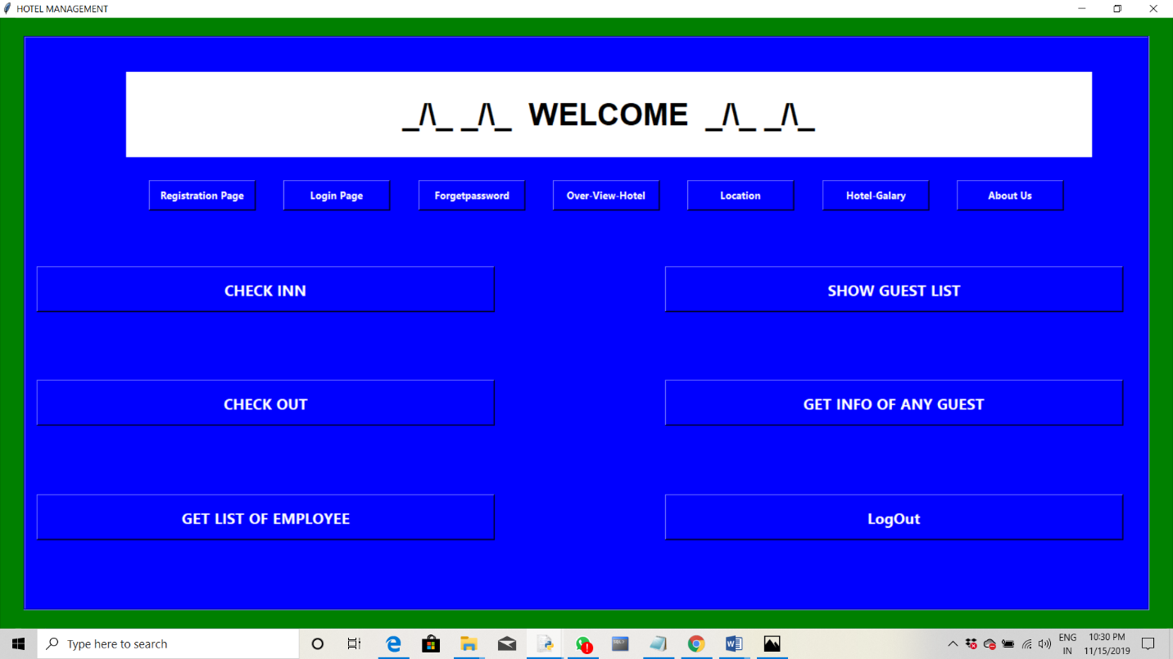

🡪GUI of Check Inn module

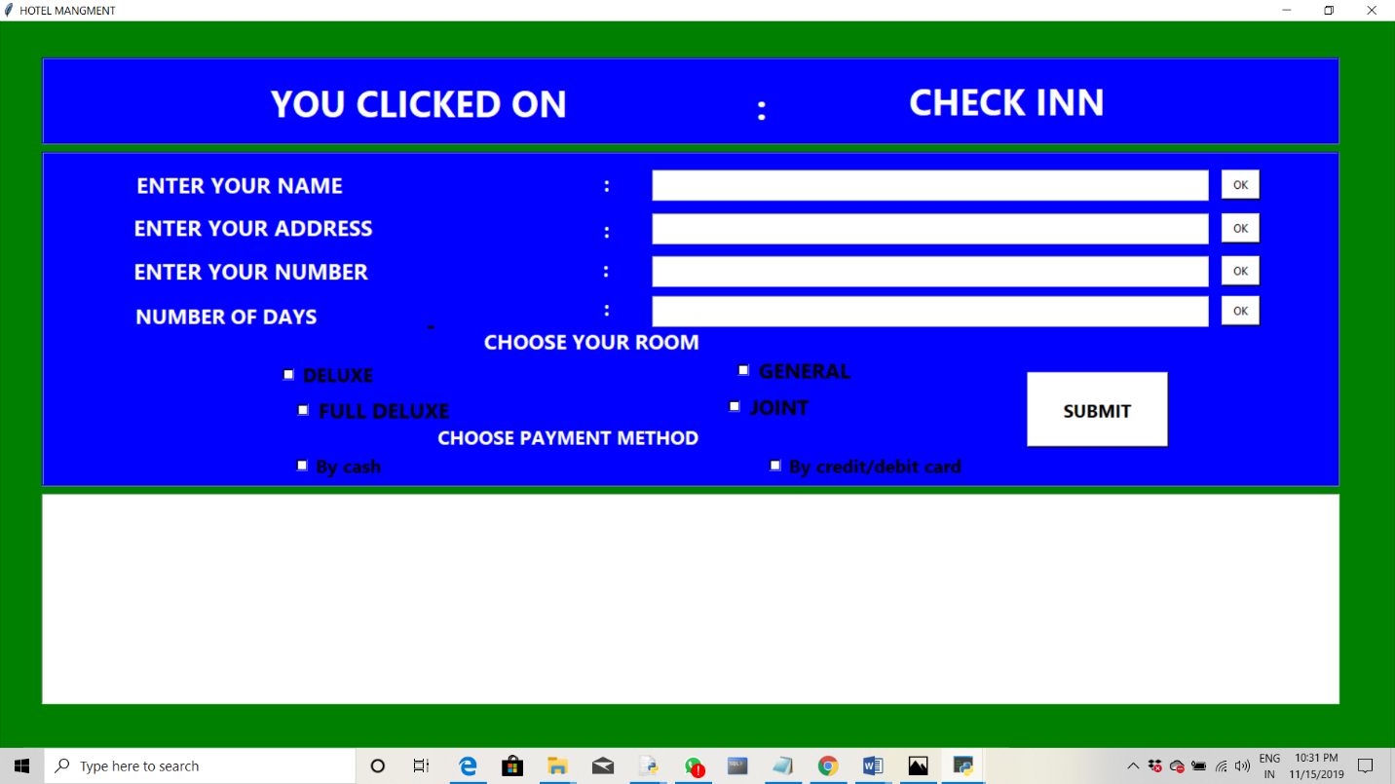

🡪GUI of show guest module

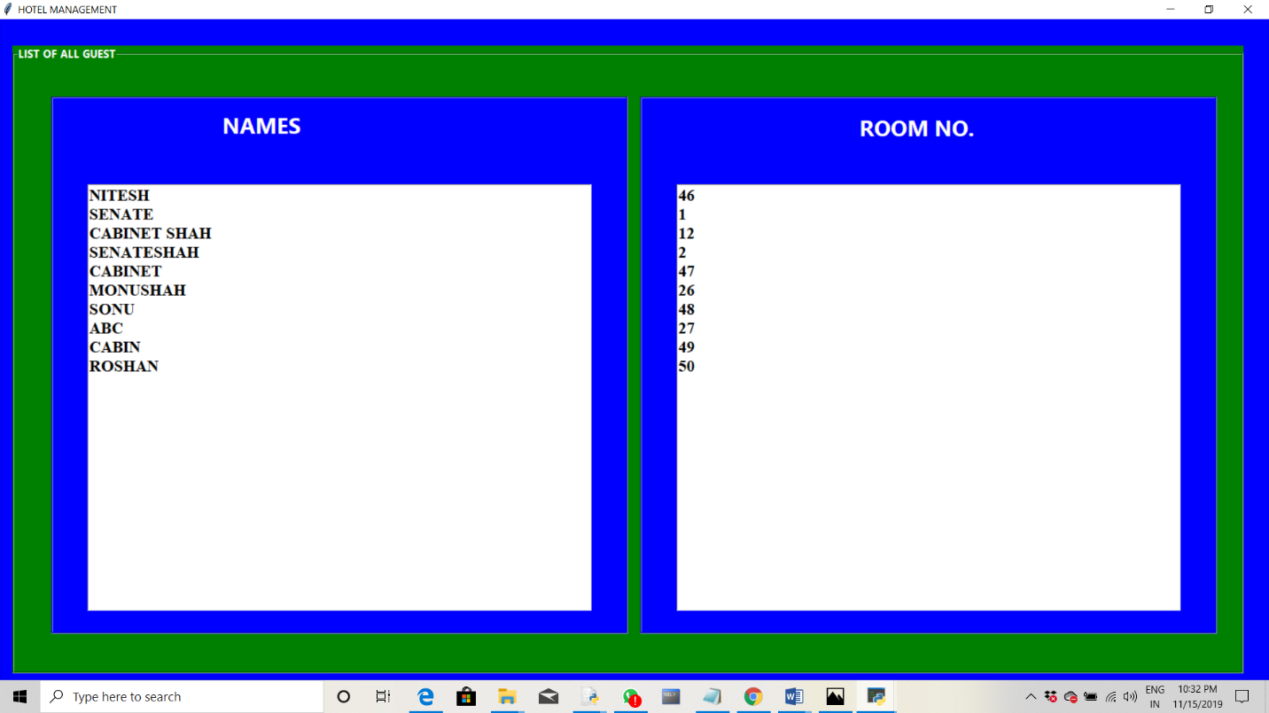

🡪GUI of check out module

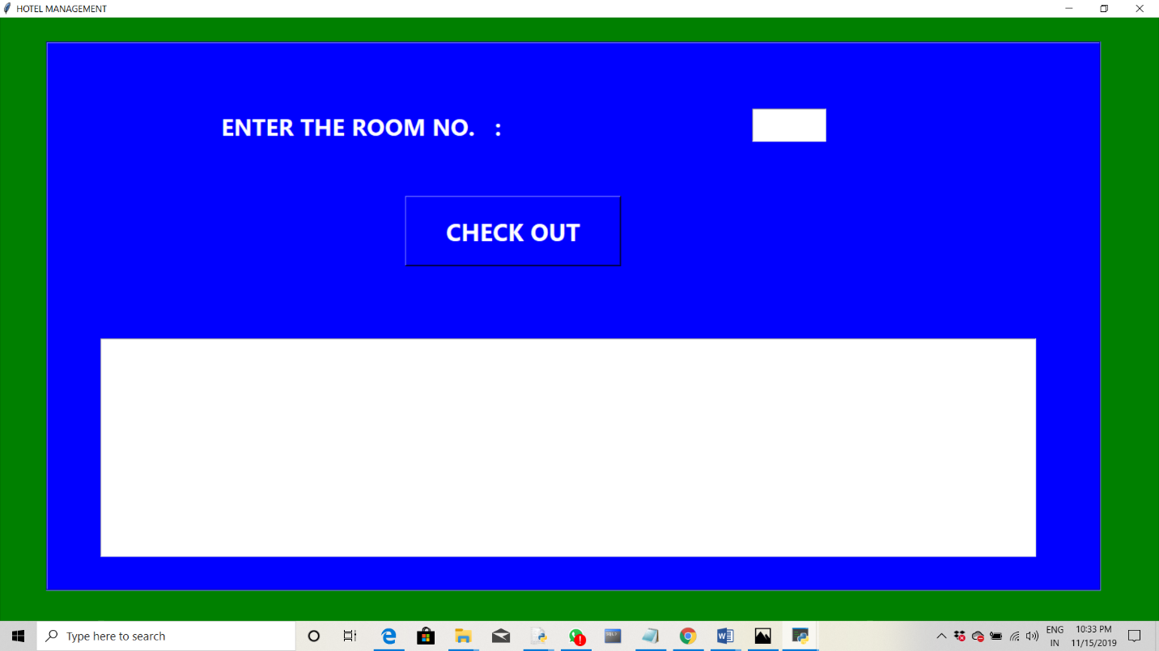

🡪GUI of Get info of any customer

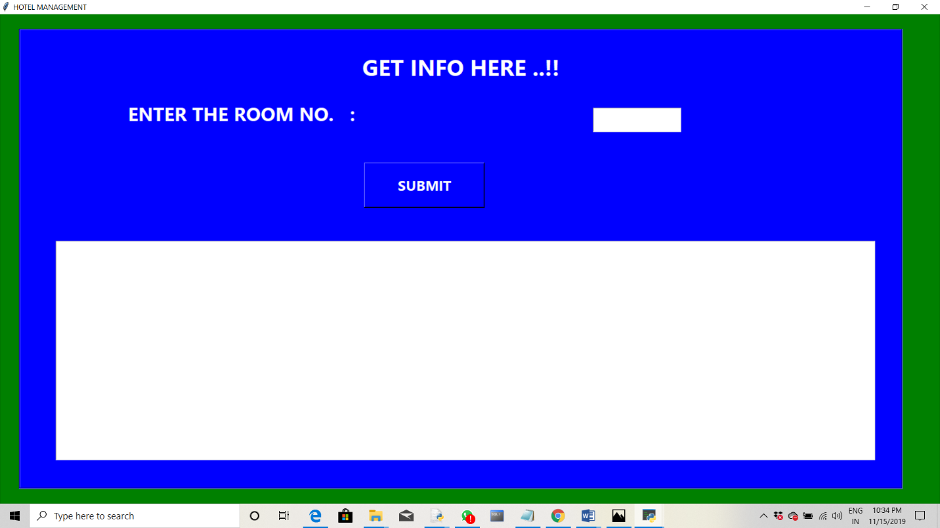

**REFERENCES:**

* HTTPS://GEEKSFORGEEKS.COM
* SAGAR PANDEY SIR
* HTTPS://TUTORIAL POINTS